Seated Bodhisattva
Student name
Institutional affiliation
Date of Submission

Seated Bodhisattva
The object chosen for this paper comes from the collection of the Saint Louis Art Museum. The title of the pieces that was conducted from the research is called Seated Bodhisattva. In Buddhism, a bodhisattva refers to any individual who is the path headed for Buddhahood. Consequently, in the last early Buddhist schools, a bodhisattva relates to a person who has resolved to become a Buddha and the person has received a forecast or validation from living Buddha that this will be so. In Mahayana Buddhism, a bodhisattva refers to any individual who has acquired a spontaneous wish and concerned mind to achieve Buddhahood for the advantage of living beings. The seated bodhisattva is also referred to as Bosatsu. It represents calm stately and full-bodied seated in a frontal thoughtful pose, his graciously held hands makes a gesture of assurance. This paper aims to discuss briefly a seated bodhisattva from a wider perspective in Buddhism.
Unlike Buddha who has gotten insight and has entered Nirvana- A state transcending rebirth, suffering, and Karma in Buddhism and are free from the endless circle of personal rebirth; Bodhisattvas have also attained formal divine enlightenment. These bodhisattvas' have delayed entering into nirvana to enlighten people on the way to spiritual enlightenment. Besides they are known for wisdom and compassion. Similarly, their sculptures are portrayed in a vague gender that represents their ability to transcend gender. This means that they can assume gender in their drive to support people
Figure 1 is a sculpture of a bodhisattva seated with crossed legs like as in yoga pose. Consequently, the Bodhisattva is sculptured in stone and has the right had raised which implies that is offering assurance or giving greeting as portrayed in a frontal posture with a soft compassionate expression and a pleasing mouth. Also, its left hand appears to hold something that overshadows the fingers. The bodhisattva gown or robe is very elaborate covering all his body which excludes one foot and neck and the head.
It is important to note that, seated bodhisattvas are often illustrated as a princess. Besides, considering its decorations the turban is used to remind the Buddhist faithful concerning spiritual and material wealth. Incorporating the details of earthliness of Bodhisattva it represents the attaining enlightenment is a human activity that is a hand activity that is not tough to get.
The seated Bodhisattva is a very significant religious object. Consequently comparing it with other Buddhist images this image is branded by various elements that are used to deliver a variety of communications. Similarly, this image was formed many years ago, thus it can be seen to offer more information concerning Buddhism in contrast to other images.
The seated Bodhisattva is associated with various hand gestures that portray different meanings. Consequently, one of the gestures tries to express a message that one should fear which means that they should not be any fear. In the second gesture, the meaning can be seen as a gesture of giving. Through this Bodhisattva shows its willingness to provide for the needs of the faithful. Furthermore, it also illustrates that selfishness should be discouraged.
According to many traditions for an individual to become a bodhisattva, he or she must proceed through ten or sometimes fourteen. Similarly, before a bodhisattva arrives at the first ground he or she must travel through the paths namely the path of accumulation and the path of preparation.
In addition to that, their chapter of ten grounds in the Avatamsaka Sutra which guides the deity concerning seated Bodhisattvas. They are also referred to as the 52 stages in a similar text. They include great Joy which is said that being close to enlightenment and determining the importance of sentient beings. Secondly is the Stainless. In this stage, a bodhisattva is free from any strains of immorality. This helps one to be pure. Again, more emphasis is put on the moral discipline meaning that being stainless. The third stage is Luminous which considers the art of patience. It reflects the importance of patience and meditation. Radiant is the fourth stage which relates to a radiating light that burns fully and opposes enlightenment. In this stage, the emphasized perfection has to do with vigour.
The fifth stage is the aspects of very difficult to train where bodhisattvas who attain this ground must strive to assist sentient beings to get maturity. In this ground what s emphasized more is meditative concentration. Transcendent is the sixth ground which implies the state of being transcendent. In this ground, wisdom is mostly emphasized. The seven ground is the go afar which emphasis is the perfection of skilful means to help others. The immovable is the eight aspects that deal only with aspiration. This comprises of one becoming able to choose his place of rebirth. Good discriminating wisdom emphasizes the virtue of understanding self and non self. The last stage is the ground of dharma which focuses on the practice of primordial wisdom.
It is important to note that bodhisattva is compassionate in refraining from entering nirvana to save others. In addition to that, it is an ideal type that may not be a representation of a historical person like Buddha. Besides, bodhisattvas have some of the features of Christian saints in which they help the worshipers.
According to Mahayana teachings, it is clear out that a Buddha is a first innate of a bodhisattva following than many lifetimes' evolvements on to Buddhahood. The sculpture in the image 1 dates from 100-300 C.E. it dates back when this sculpture was created. The concept of a seated Bodhisattva is in philosophical terms associated with the rise of Mahayana. This relates to a branch of Buddhahood through which everybody is given a chance to enter into Buddhahood. Consequently, in this path being compassionate to work on behalf of the worshippers' spiritual goals helped to make the faith more available to a very large number of people. In this regard is important that this art effectively helped to spread the faith into central Asia and even the whole world.
In the figure below it comprise of different characteristics. The statue character, for example, the tall ornate crown and dropping folds illustrates that the statue was likely introduced by the school Buddhist monk. Consequently, it is distinguished from Buddha because it comprehensively adorned. Furthermore, it is chosen to remain with the ties to the earthly realm. The bodhisattva's statues in most cases are carved using stone or mental.
In summary, the seated Bodhisattva reflects a compassionate creature who has chosen to remain on the face of the earth to assist mortals to attain their enlightenment. It is important to know that bodhisattva came to signify those who are seriously willing to share and dedicate their lives to Buddhism. Similarly, the word bodhisattva initially comes from Sanskrit. The seated Bodhisattva is associated with countless hand gestures that portray different meanings. Consequently, one of the gestures tries to express a message that one should fear which means that they should not be any fear. It has many gestures to portray different meanings.

Bibliography
Gangopadhyay, Purabi. "Buddhist iconography a comparative study in India and outside India." (2016).
Hong, Seonghyuk, Young Hoon Jo, Yoon Mi Kwon, and Seong Yeon Jo. "Restoration of the Damaged Korean Stone Seated Bodhisattva Sculpture Using Three-dimensional Virtual Modeling and Printing Technologies." In 2018 3rd Digital Heritage International Congress (DigitalHERITAGE) held jointly with the 2018 24th International Conference on Virtual Systems & Multimedia (VSMM 2018), pp. 1-3. IEEE, 2018.
Once a Peacock, Once an Actress: Twenty-Four Lives of the Bodhisattva from Haribhatta's" Jatakamala". University of Chicago Press, 2017.

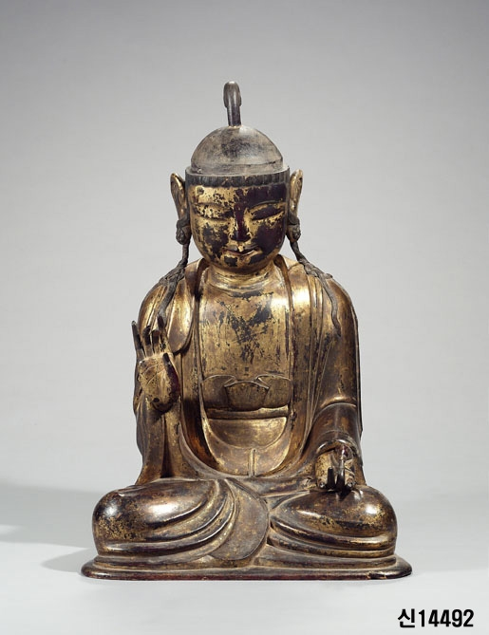
Figure 1

Haribhatta's Jatakamala" Once a Peacock, Once an Actress: Twenty-Four Lives of the Bodhisattva University of Chicago Press, 2017.
Gangopadhyay, Buddhist iconography a comparative study in India and outside India. Oxford university press. 157.
Hong, et al. "Restoration of the Damaged Korean Stone Seated Bodhisattva Sculpture Using Three-dimensional Virtual Modeling and Printing Technologies 17-100
Ibid, 45
Ibid.
Ibid.

